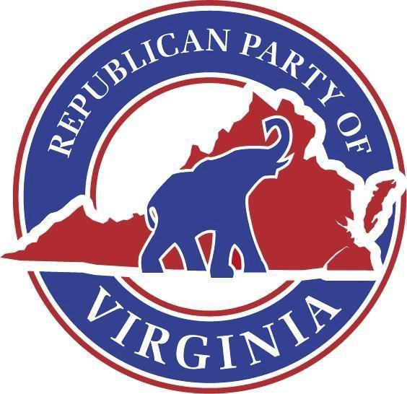

Republican Party of Virginia

[*www.Virginia.GOP*](http://www.virginia.gop/)

Official Call of the State Central Committee

*Issued August 24, 2024*

I, Richard L. Anderson, Chairman of the Republican Party of Virginia, do hereby call for a meeting of the RPV State Central Committee on **Saturday, September 14th, at 11:00 am**. The meeting will occur at the Virginia Manufacturers Association, located at 2112 W Laburnum Ave # 205, Richmond, VA 23227.

The agenda shall be as follows:

1. Call to Order
2. Invocation
3. Pledge of Allegiance
4. Republican Creed
5. Appointment of a Proxy Committee
6. Roll Call
7. Report of the Proxy Committee
8. Adoption of the Minutes
9. Auxiliary Reports
10. Chairman’s Report
11. Unfinished Business and General Orders
    1. Election of SCC Officers
12. New Business
13. Executive Session
14. Return to Open Session
15. Closing Announcements
16. Benediction
17. Adjournment

The Richard D. Obenshain Center • 115 East Grace Street • Richmond, Virginia 23219   
 804-780-0111