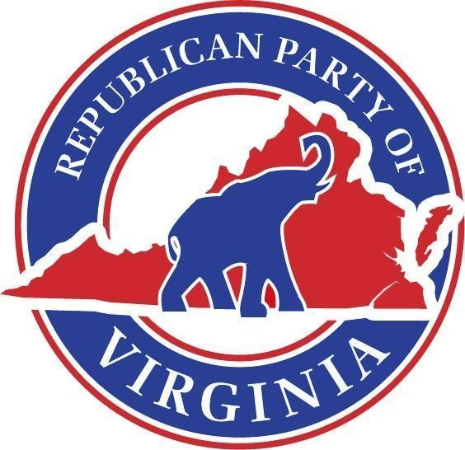

Republican Party of Virginia

[*www.Virginia.GOP*](http://www.Virginia.GOP/)

# Official Call of the SCC Executive Committee

*Issued August 24, 2024*

I, Richard L. Anderson, Chairman of the Republican Party of Virginia, do hereby call for a meeting of the Executive Committee of the RPV State Central Committee on **Saturday, September 14th, at 10:00 am.** The meeting will occur at the Virginia Manufacturer’s Association, located at 2112 W Laburnum Ave # 205, Richmond, VA 23227.

The agenda shall be as follows:

1. Call to Order
2. Appointment of a Proxy Committee
3. Roll Call
4. Report of the Proxy Committee
5. New Business
6. Adjournment

The Richard D. Obenshain Center • 115 East Grace Street • Richmond, Virginia 23219 804-780-0111

PAID FOR AND AUTHORIZED BY THE REPUBLICAN PARTY OF VIRGINIA. CONTRIBUTIONS ARE NOT TAX DEDUCTIBLE.

